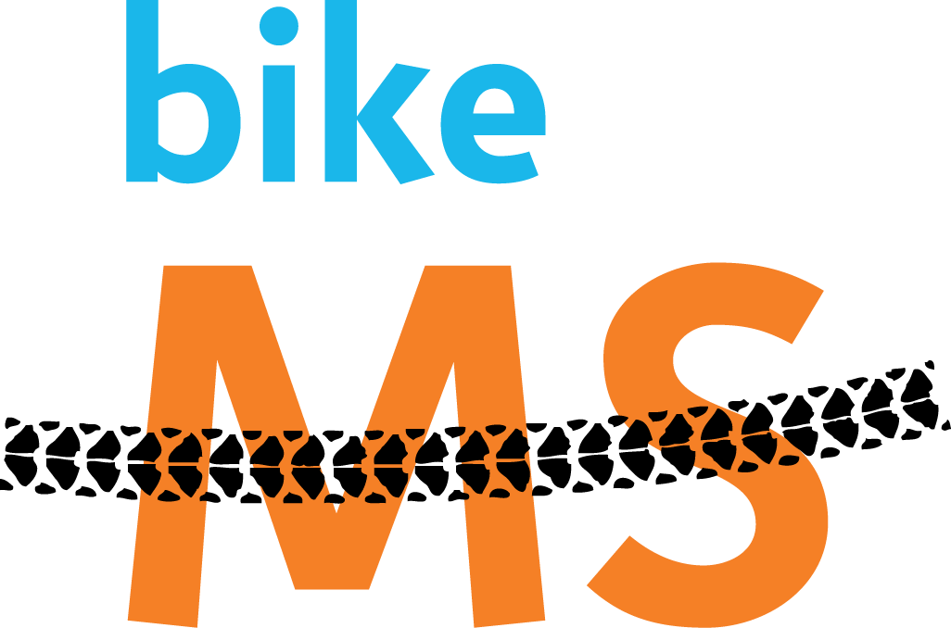

Training for BIKE MS: Historic New Bern Ride

- You can do Bike MS!
- Equipping yourself for Bike MS
- Training for Bike MS
  - Training Program to Finish
    - Train to Finish – Training Schedule
  - Training Program to Finish Faster
    - Train to Finish Faster – Training Schedule
- Getting Drafted
  - Safe Drafting and Pace Line Etiquette

You can do Bike MS!
Cycling 150 miles in 2 days. Who, me?! Friends and family probably think you’re crazy to attempt this extraordinary feat. Use that reaction to motivate you in your training – as well as in your fundraising (“Sponsor me in my death-defying attempt to ride 150 miles in 2 days…”).
Those who have trained for and completed Bike MS know that almost anyone in decent health, with preparation, can complete the BIKE MS. Consider:
- Bike MS is not a race. You have all day to finish.
- It's FLAT! Riding around New Bern is nothing like riding "inland". The only hills consist of a few bridges. Flat riding is much easier.
- Because it's FLAT, if you can ride 40-45 miles around central NC, you can do 75 miles a day around New Bern. Honestly!
- Don't fret about 150 miles. Think about each day as a series of 12 miles rides. Ride 12 miles to the next rest stop. Get off the bike, stretch, have something to eat and drink, chat with friends (and meet new friends). Then do another 12 mile ride.
- You will never find a better-organized and more fun ride than Bike MS! There are those rest stops with a variety of food and drink. Lunch at the midpoint rest stop. Freshly-made ice cream. Finish line celebration lunch after the ride Sunday. Marked route and cue sheets. Great volunteers, SAG support, mechanical support, medics, massage therapists, quiet rural roads, great Saturday evening dinner and activities, and much, much more.
- Teams make training and participating even more fun.
- Did I mention that it's FLAT?
- If you find that you just can't ride day 2, then don't.
- If you find that you just can't finish either day's route, there are SAG vehicles that can give you (and your bike) a ride to the next rest stop or to the finish.
-- back to top --

Equipping Yourself for Bike MS
Part of the preparation for Bike MS is physical, part is building your confidence, and part is getting properly equipped. Prepare your bike. You don't need a sleek, featherweight race bike. Almost any bike in good condition will work (although I would not recommend using a heavy full-suspension mountain bike). Some tips to keep in mind:
- If your bike hasn't been used much or isn't in great shape, have your local bike shop inspect it and/or tune it up. (An inspection is free at participating bike shops and is strongly encouraged before Bike MS).
- If you bike has fat, knobby tires, have your local bike shop replace them with "slicks" thinner, smoother, higher-pressure tires. They greatly reduce rolling resistance, making your ride much easier (or much faster at the same effort). This is important!
- Get a good pair of padded cycling shorts (tight or baggy - your choice) and some chamois cream. (Don't make the rookie mistake of wearing underwear with your padded cycling shorts.)
- Get some padded cycling gloves to minimize hand numbness. You must have a helmet.
- Get a good floor pump and be sure to pump up your tires to the recommended pressure (listed on the tire) before every ride. The number one cause of flat tires is too little air pressure!
- The must-have basics include: bike, helmet, padded shorts, cycling gloves, floor pump, repair kit.
-- back to top --

Training for Bike MS
There are generally two goals participants training for Bike MS have: Finishing or Finishing Faster.

Training Program to Finish
New or novice cyclists, first time participants, and those just out to have fun for a great cause often prepare with the goal of being able to walk away from the weekend having successfully ridden 150 miles in 2 days. Completing Bike MS does take preparation and training. I tell people (half-jokingly) that the best way to train for the BIKE MS is to replace your office chair with a bicycle seat. A big part of preparing for Bike MS is getting your butt used to spending extended periods in the "saddle." If you’re not an avid cyclist, you’re likely to find that just by riding a couple of times a week and gradually increasing your once weekly “long ride” will get you ready.

Build up your mileage gradually throughout the summer. As you extend your route, include more hills so that your rides get both longer and more challenging. Pay now or pay later – there is no substitute for getting in the training miles! With a lack of training you’ll likely still be able to finish the Bike MS, you just won’t be as happy at the finish line. Planning routes of increasing distance and challenge can be time consuming, and many new riders are not comfortable out on the road alone. Consider participating in Official BIKE MS Training Rides. Visit http://bikenct.nationalmssociety.org/site/PageServer?pagename=BIKE_NCT_TrainingSeries for up-to-date information on upcoming training rides.

Train to Finish – Training Schedule
A sample “Train to Finish” schedule in Table 1 summarizes the number of rides and long ride distance for each week. Long rides are specified for beginner cyclists and for more experienced cyclists ready to start off with longer rides. Additional rides during the week can be any distance – but should be shorter than your long ride. When riding more than 2 days in a week, be sure to make one ride a true slow, easy recovery ride with a focus on keeping your breathing easy. Weeks start on Mondays so that you can get end each week with the long ride any time on the weekend. Work some hills into your training rides. Yeah, they are hard, but there's no faster way to build your cycling strength and endurance. If you’re progressing well and want to build more speed, considering incorporating elements of the Training Program to Finish Faster.

Table 1: Train to Finish Schedule
Week Of | Total # Rides | Beginner Cyclists – Long Ride (miles) | Moderate Cyclist – Long Ride (miles) | Comments
April 28 | 2 | 10 | 18
May 5 | 2 | 10 | 18 | Bike MS Kick Off Ride – May 3rd
May 12 | 2 | 12 | 21 | Biking with the Band – May 17th
May 19 | 2 | 12 | 21 | “Peddling for MS & Missions” – May 31st
May 26 | 2 | 15 | 21
June 2 | 2 | 15 | 27
June 11 | 2 | 19 | 27
June 16 | 2 | 19 | 27
June 23 | 2 | 23 | 33
June 30 | 2 | 23 | 33
July 7 | 2 | 26 | 33
July 14 | 2-3 | 26 | 39
July 21 | 2-3 | 29 | 39 | Cup n’ Cone Tour – July 26th
July 28 | 2-3 | 32 | 39
Aug 4 | 2-3 | 36 | 45
Aug 11 | 2-3 | 40 | 45
Aug 18 | 2-3 | 45 | 52
Aug 25 | 2-3 | 40 | 45
Sept 1 | 2 | 40 | 52
Sept 8 | 1 | 15 | 21 | Bike MS Week! No cycling from Wednesday - Friday

-- back to top --

Training Program to Finish Faster
More experienced cyclists and those who have a couple of Bike MS events under their belts are likely to have more aggressive goals than simply finishing in one piece. Their thoughts often turn to picking up the pace – and pace lines – and riding faster and finishing sooner. There are two aspects to building the combination of speed and endurance required to go long and fast: power and endurance. Cycle all summer long at increasing distances at a constant speed/effort and you’ll build the endurance to successfully complete the BIKE MS. That’s the Training Program to Finish.

Intro to Intervals
To ride faster, you need to ride faster. That seems obvious, but many folks develop a routine in which they train at the same steady pace and effort week in and week out and get frustrated that they don’t get faster. By replacing some of the constant effort distance with power-development training, your speed will gradually increase. Power development can be accomplished by alternately working very hard and easing up to recover. This intense/recovery “interval” is repeated several times. As your training progresses, increase both the intensity and duration of the hard portion of the interval (allowing sufficient time to recover) and add additional intervals. This is called interval training.
Intervals can consist of “hill repeats” – strenuous riding up a hill at high effort followed by a recovery period (while going back downhill), then repeating. Over time the length of the climb (and potentially the steepness of the grade) should increase. Interval training can also be done on flatter ground by simply pushing yourself to ride very hard (so that you are breathing too hard to hold a conversation) for a period of time, easing way up to recover, then repeating. The key is to repeatedly raise your effort to a high level, sustain that level for a period of time, then allow your body a period of time to recover. Interval training should be limited to once (or at most twice) per week and should be followed by a rest day or very easy recovery ride day. This stress-and-recover interval training is key to adding power to your endurance, and that power translates to the ability to complete the BIKE MS at a higher average speed. In addition to interval training, the ability to generate power can be supplemented with leg and core strength work in the gym or pilates or yoga class.

Road to Recovery
Working your body hard actually tears down your body. Lactic acid builds up and microtears break down muscle fibers. It is actually during rest and recovery periods that the lactic acid is flushed, micro-tears heal, and your strength increases. Be sure to include a very easy recovery ride or rest day on the day after your intervals. At a macro level, think of your training weeks as intervals, as well, with easy “recovery weeks” interspersed with your hard weeks. During a recovery week, replace your interval training ride with a very easy, low heart rate recovery ride.

Train to Finish Faster – Training Schedule
The sample Train to Finish Faster schedule in Table 2 summarizes the number of rides, intervals, and long ride distance for each week. When riding more than 3 days in a week, be sure to make one ride a true slow, easy recovery ride with a focus on keeping your breathing easy. Intervals are described as the number of iterations and the duration of the hard effort. Recovery time between iterations should be long enough to fully recover to easy breathing (generally 1-3 minutes). Weeks start on Mondays so that you can get end each week with the long ride any time on the weekend.

Table 2: Train to Finish Faster
Week Of | Total # Rides | Intervals | Long Ride (miles) | Comments
April 28 | 2-3 | 3 x 30 sec | 25
May 5 | 2-3 | 3 x 30 sec | 25 | Bike MS Kick Off Ride – May 3rd
May 12 | 2-3 | 4 x 30 sec | 30 | Biking with the Band – May 17th
May 19 | 2-3 | Recovery Week | 30 | “Peddling for MS & Missions” – May 31st
May 26 | 2-3 | 4 x 60 sec | 30
June 2 | 2-3 | 4 x 60 sec | 37
June 11 | 2-3 | 2 x 2 min | 37
June 16 | 2-3 | Recovery Week | 37
June 23 | 2-3 | 4 x 2:00 | 45
June 30 | 3-4 | 4 x 2:30 | 45
July 7 | 3-4 | 5 x 2:30 | 52
July 14 | 2-4 | Recovery Week | 52
July 21 | 3-4 | 4 x 3:00 | 58 | Cup n’ Cone Tour – July 26th
July 28 | 3-4 | 4 x 3:00 | 58
Aug 4 | 2-4 | Recovery Week | 62
Aug 11 | 3-4 | 5 x 3:00 | 62
Aug 18 | 3-4 | 5 x 3:00 | 68
Aug 25 | 3-4 | 5 x 3:00 | 68
Sept 1 | 2-3 | Taper Week | 62
Sept 8 | 1 | 15 | 21 | Bike MS Week! No cycling from Wednesday - Friday

-- back to top --

Getting Drafted
The “secret weapon” that most every experienced cyclist has in his or her arsenal is the ability to ride safely in a pace line. By riding closely behind another cyclist, you enjoy the benefit of reduced wind resistance in that cyclist’s slip stream. This is known as “drafting”. The result is faster speed for the same effort (or lower effort at a given speed). String a line of cyclists together (a “pace line”), and the effect can increase. As speed goes up, the benefit of drafting increases to the point where you can achieve as much as 30% faster speed for the same effort.
New and intermediate cyclists tend to be very worried about cars on the road. Not that you shouldn’t worry about cars, but most cycling accidents are bike-on-bike. Drafting and pace line riding requires that you learn and practice skills and constantly stay alert. A momentary lapse can result in tire overlap and tire contact which can bring you down – along with everyone in line behind you. Pace line riding is safest when everyone in the line is experienced in pace line riding – and preferably with one another. Danger increases when cyclists you are not familiar with join in – especially when those cyclists are not experienced in drafting. Do not hesitate to ask someone to leave your pace line if they are endangering everyone else in the line.

Safe Drafting and Pace Line Etiquette
Safe drafting and pace line riding is all about communication, consistency, and predictability. The cyclist at the front of the line (the “leader”) is responsible for setting the pace and choosing the “line” to avoid obstacles and dangers. The leader must be careful to maintain a steady effort level – even if hills and wind direction cause actual speed to change. When the leader rotates back, the tendency of the new leader is to speed up. That will stress and possibly break apart the line. While you are the second rider, note the current speed and when the leader pulls out to rotate back, focus on maintaining that speed. Each cyclist is responsible for the safety of everyone else in line. The leader at the front of the line has a special level of safety responsibility. It is up to the line leader to spot, avoid, and clearly communicate (with as much notice as possible) any dangers or obstacles such as “gravel”, “hole”, oncoming cars (“car up”), etc. The rider(s) at the back are responsible for clearly communicating when a car is coming up from behind (“car back”) so that no one inadvertently pulls out into traffic (such as when the leader pulls out to rotate back). Everyone else down the line is responsible to pass this information up and down the line. Pace line riding is a learned skill that must be practiced. Look for pace line training rides in which an experienced cyclist will explain and demonstrate pace line communication and techniques. Start learning with a safe distance between your front wheel and the wheel in front of you (e.g. 2 feet). Over the season, gradually tightening the distance to a few inches as you gain experience and confidence.

The following Pace Line safety and etiquette tips were provided by Tom Misiak of BIKE MS Team Nortel:
- Help the weakest person. A pace line is a team effort and it's only as strong as its weakest member.
- Get used to following closely to maximize the benefit of a draft. Give yourself a little extra space, however, when drafting someone you've never ridden with before.
- Do not abruptly change your course
- When pulling off the front, first glance back to make sure the rider behind you isn't lapping your wheel or that a car isn't getting ready to pass you, then without changing your pace move to the left about a shoulder width away from your original position.
- Once the person in front of you pulls off, glance at your cyclometer and keep the speed constant until that person makes it back into the paceline (the tendency is to accelerate).
- Ride predictably and smoothly. Never accelerate or brake quickly. If you are running up on the wheel in front, slow down, without braking, by reducing the force to the pedals or moving into the wind slightly.
- If the rider at the front charges off, let that person go and hold your speed.
- Riders behind you often cannot see road hazards. When leading the paceline, everyone's safety is your job, so be sure to lead them around all obstacles (point down on right or left to identify hazards or announce them ie, "gravel right" and ride around them)
- Pull off the front before you blow; this will leave you with enough energy to fall back into the paceline behind the last rider and recover from your pull
- By rotating frequently, each person gets a good workout while the whole group travels more efficiently at a greater speed
- Do not drink or eat unless you're the last person in the paceline
- Do not use aerobars unless you're at the front of the paceline; you have less control of the bicycle while using aerobars and are further away from the brake levers in case you need them
- If you tire, sit out as many turns as necessary by staying at the back. Let the riders coming back know that you're resting and give them space to move in ahead of you.
- As the speed increases, gaps may develop as the weaker riders can't hold the wheel ahead or the riders moving back miss the last wheel. Stronger riders need to fill these gaps, even if it means jumping around the weaker rider(s) to fill the gap in front of them.
- It is probably not a good idea to stand up while you're anywhere other than the back of the paceline, but if you do need to stand, be sure to stand up while your crank is in the 2 o'clock position. By applying power to the crank as you stand up you will avoid "kicking" the rider behind you (If you stand while not applying power to the crank, your bike will slow down and almost seem to jump back a few inches possibly causing anyone behind you to crash).
-- back to top --

